A new venue for meetings, with a Welcome Pack for members, getting to grips with Zoom, guest speakers, more critiques and our 135th Anniversary celebrations coming up in November there’s a lot happening even with the current restrictions on meetings.

  - Newsletter | Issue 2
Autumn 2020
Read All About It!

Herefordshire

Photographic

Society

Est 1885

SNAPSHOT

In view of the need for social distancing it was considered that our old venue of the committee room at Bartestree Village hall would be too small and after looking at a variety of venues we have now gained use of Breinton Village Hall (HR4 7PJ) on the 3rd Friday of each month. This rural setting should give us inspiration for our work. However, due to current restrictions we are unable to meet at Breinton for the time being but hope to meet there soon.
A New Venue and a new day
Photo Buddy
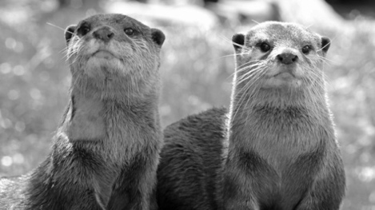
How will it work? There are two parts to the Photo Buddy, firstly, as a point of contact when we’re out visiting places of interest on club outings.
The Photo Buddy will be available to provide you with any help and support that you might need - especially if you’re new to photo shoots and not sure how to get started. If you need support, the Photo Buddy will be introduced to you on the day so if you do get stuck, you’ll know exactly who to ask.

Secondly, the Buddy system can provide an opportunity to enable similar kit users in the Club to come together to exchange tips and ideas with each other.
Welcome Pack
As a Full Member of HPS you will be given a folder containing your membership card & receipt, our current newsletter, a Who’s Who of Committee members, a copy of our current events programme, The London Camera Exchange Club discount details, together with your own ‘Club Mug’.
Our new Quarterly Newsletter
SNAPSHOT
Please email us (c/o Clive) anytime with your questions, photo visits, feedback or tips and kit updates – we’d love to hear what you think!
The Team
The HPS Committee. Phil Chapman Chairman, Amanda Apps Secretary, John Hardwick Treasurer, Clive Handscombe Media Representative & Newsletter co-ordinator, with Steve Morgan and Paul Rees as Committee members. As a group, we are busy planning HPS’s future; events, speakers and inter-club battles so we hope that you enjoy what we have in store.
Our Anniversary
On 19th November 2020 HPS will be marking the 135th anniversary of the society which was to have been celebrated at Breinton Village Hall, however with current restrictions on meetings this is now in doubt.
We will keep you updated with all the details about the plans for the events as they unfold and of a future date if that becomes necessary.
Our Website
Please view our website at www.herefordshirephotographicsociety.co.uk
for full up to date information about our society including the programme and details of the upcoming critiques. I have room on the website in the members gallery of photos to display more images so please send me a selection that you would like to have included.
A.O.B.
1. Amateur Photographer Magazine, - Focus Stacking – How to achieve pin sharp macro shots (published 16th June 2020) (use the link below):
http://www.amateurphotographer.co.uk/technique/macro_photography/focus-stacking-how-to-achieve-pin-sharp-macro-shots-137846
2. Amateur Photographer Magazine – Eco Friendly printing. (use the link below)
http://www.amateurphotographer.co.uk/latest/articles/eco-friendly-printing-137777
*NOTE: The information and articles above have been provided in good faith and we would emphasize that as Laws and Customs can change it is always worth checking directly with a Legal expert should you have any specific queries or concerns about your rights or responsibilities as a photographer on this subject.

